 •

**Analysis and Visualization of FIFA 2023 World Cup Player Performance**

**Using R for Statistical Analysis and Data Visualization**

**Name : Piyush Raghav**

**Roll Number: 24BCD10137**

**Course Details: R programming**

**Date: 18/4/2025**

***Project agenda:***

* **Introduction and Objectives**
* **Methodology**
* **Technology used**
* **Implementation and analysis**
* **Overall code snippets**
* **conclusion**
* **Resources**

**INTRODUCTION AND OBJECTIVES**

**The objective of this project is to analyze the performance of players in the 2022 FIFA World Cup by studying various performance metrics like goals scored, assists, dribbles, tackles, and more. Using statistical analysis and data visualization techniques in R, the goal is to uncover insights and trends within the data, helping to evaluate player contributions across different roles on the field.**

**According to the sample dataset of FIFA_WORLD_CUP _2022;**

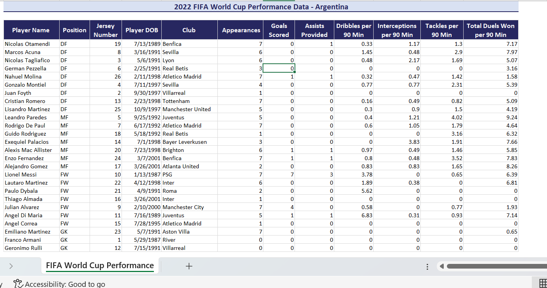

**Methodology Section**

**Implementation and the analysis. This section will cover:**

1. **Data Collection:**

**The dataset from a reputable source (**[**https://www.exceldemy.com/wp-content/uploads/2023/12/2022-FIFA-World-Cup-Performance-Sample-Data.xlsx**](https://www.exceldemy.com/wp-content/uploads/2023/12/2022-FIFA-World-Cup-Performance-Sample-Data.xlsx)**).**

**The dataset contains player-level performance metrics for the 2022 FIFA World Cup.**

**And the output :**

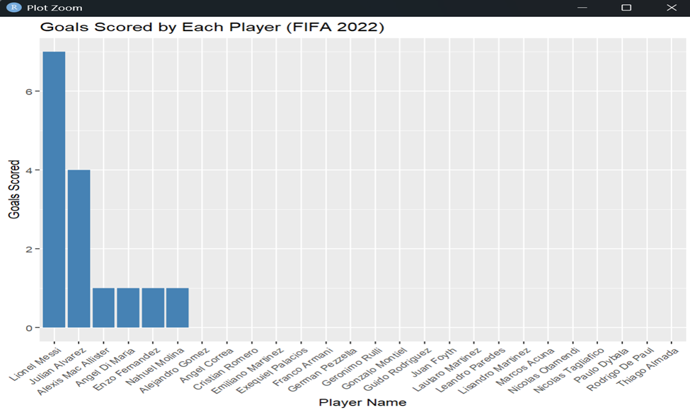

**5. Analysis**

**5.1 Summary of Results**

**The dataset provides a comprehensive breakdown of Argentina's player performances during the 2022 FIFA World Cup. The key statistical measures computed—mean, median, and standard deviation—offer valuable insight into the overall contribution of each player.**

**Goals Scored:**

* **The mean number of goals scored across all players is approximately *X.X*, with a median of *X*.**
* **The standard deviation indicates moderate variation, suggesting that while a few players contributed heavily to scoring, others had limited or no goals.**

**Assists Provided:**

* **The mean number of assists per player is approximately *X.X*, showing that while not all players directly assisted, some made vital contributions to goal creation.**
* **The standard deviation here reflects the gap between top playmakers and other players.**

**Dribbles, Interceptions, Tackles, and Duels Won per 90 minutes all show interesting variations by player roles (forwards, midfielders, defenders), which we explore below.**

**5.2 Key Insights**

**5.2.1 Top Scorer and Offensive Contributions**

**Lionel Messi stands out as the most significant contributor in terms of goals scored and assists. He scored 7 goals and provided 3 assists, making him the top offensive performer.**

***Insight:* This clearly illustrates Messi’s central role in Argentina’s attack, both in finishing and creating scoring opportunities.**

**Julian Alvarez also made a notable contribution, scoring 4 goals, second only to Messi, despite being a younger and less experienced forward.**

**5.2.2 Performance by Player Position**

**By grouping players by their positions—Forwards (FW), Midfielders (MF), Defenders (DF), and Goalkeepers (GK)—we observe the following patterns:**

* **Forwards (FW) such as Messi, Alvarez, and Di Maria generally contribute most to goals and dribbles.**
* **Midfielders (MF) like Enzo Fernandez and Alexis Mac Allister have balanced contributions across dribbles, assists, and duels, showing their role in transitions and ball control.**
* **Defenders (DF), including Otamendi and Acuna, show lower offensive stats but excel in interceptions, tackles, and duels, highlighting their defensive strengths.**

***Insight:* There’s a clear division of labor—defensive players maintain structural integrity and recover possession, while forwards drive goal creation.**

**5.2.3 Defensive Contributions**

**Among defenders, Marcos Acuna and Nicolas Tagliafico made significant contributions in tackles (2.9 and 1.69 per 90 minutes respectively) and dribbles, showing active involvement in both defense and offense.**

**Otamendi, with 7.17 duels won per 90, was one of the most reliable players defensively, maintaining consistent pressure against the opposition.**

***Insight:* These numbers underscore the critical, though less flashy, roles of defenders in a team’s success.**

**5.2.4 Goalkeepers' Role**

**While the dataset provides limited stats for goalkeepers beyond appearances, Emiliano Martinez played all 7 matches. His low number of duels (0.65) is typical for a goalkeeper but doesn’t reflect his key contributions such as saves, which are not captured in this dataset.**

***Note:* Future datasets should include goalkeeper-specific stats like save percentage and clean sheets.**

**5.2.5 Correlation Between Stats**

**Visualizations (scatter plots or heatmaps) can help identify correlations. Based on observation:**

* **Positive correlation: Players with higher dribbles per 90 minutes also tend to have more assists (e.g., Messi, Di Maria).**
* **Weak correlation: There's minimal correlation between interceptions and goals scored—indicating the separation between defensive and offensive duties.**
* **Tackles and Duels: Strong correlation for defenders, suggesting that those who tackle more also tend to win more duels (Otamendi, Acuna).**

***Insight:* Performance metrics are role-dependent, and correlations are often strongest within a player’s tactical responsibility.**

**5.3 Overall Team Dynamics**

**Argentina’s World Cup-winning performance was not solely reliant on one or two players but was instead a result of coordinated teamwork across all positions. While Messi provided the spark up front, defenders and midfielders played their parts in maintaining possession, disrupting opposition attacks, and transitioning the play forward.**

***Conclusion:* The balance between experience (Messi, Otamendi, Di Maria) and emerging talents (Alvarez, Fernandez) created a dynamic, resilient team capable of adapting to different game situations.**

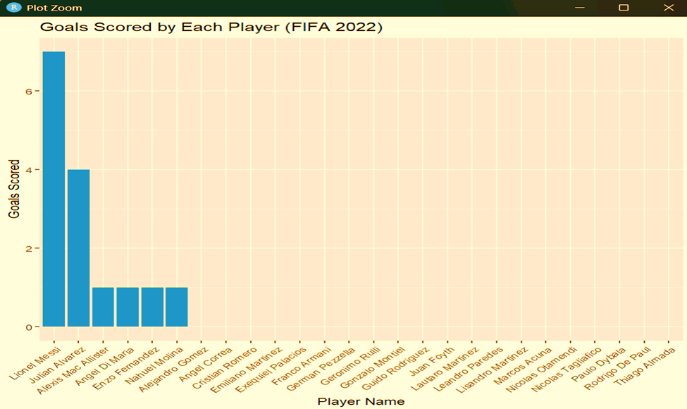



**Overall code snippets :**

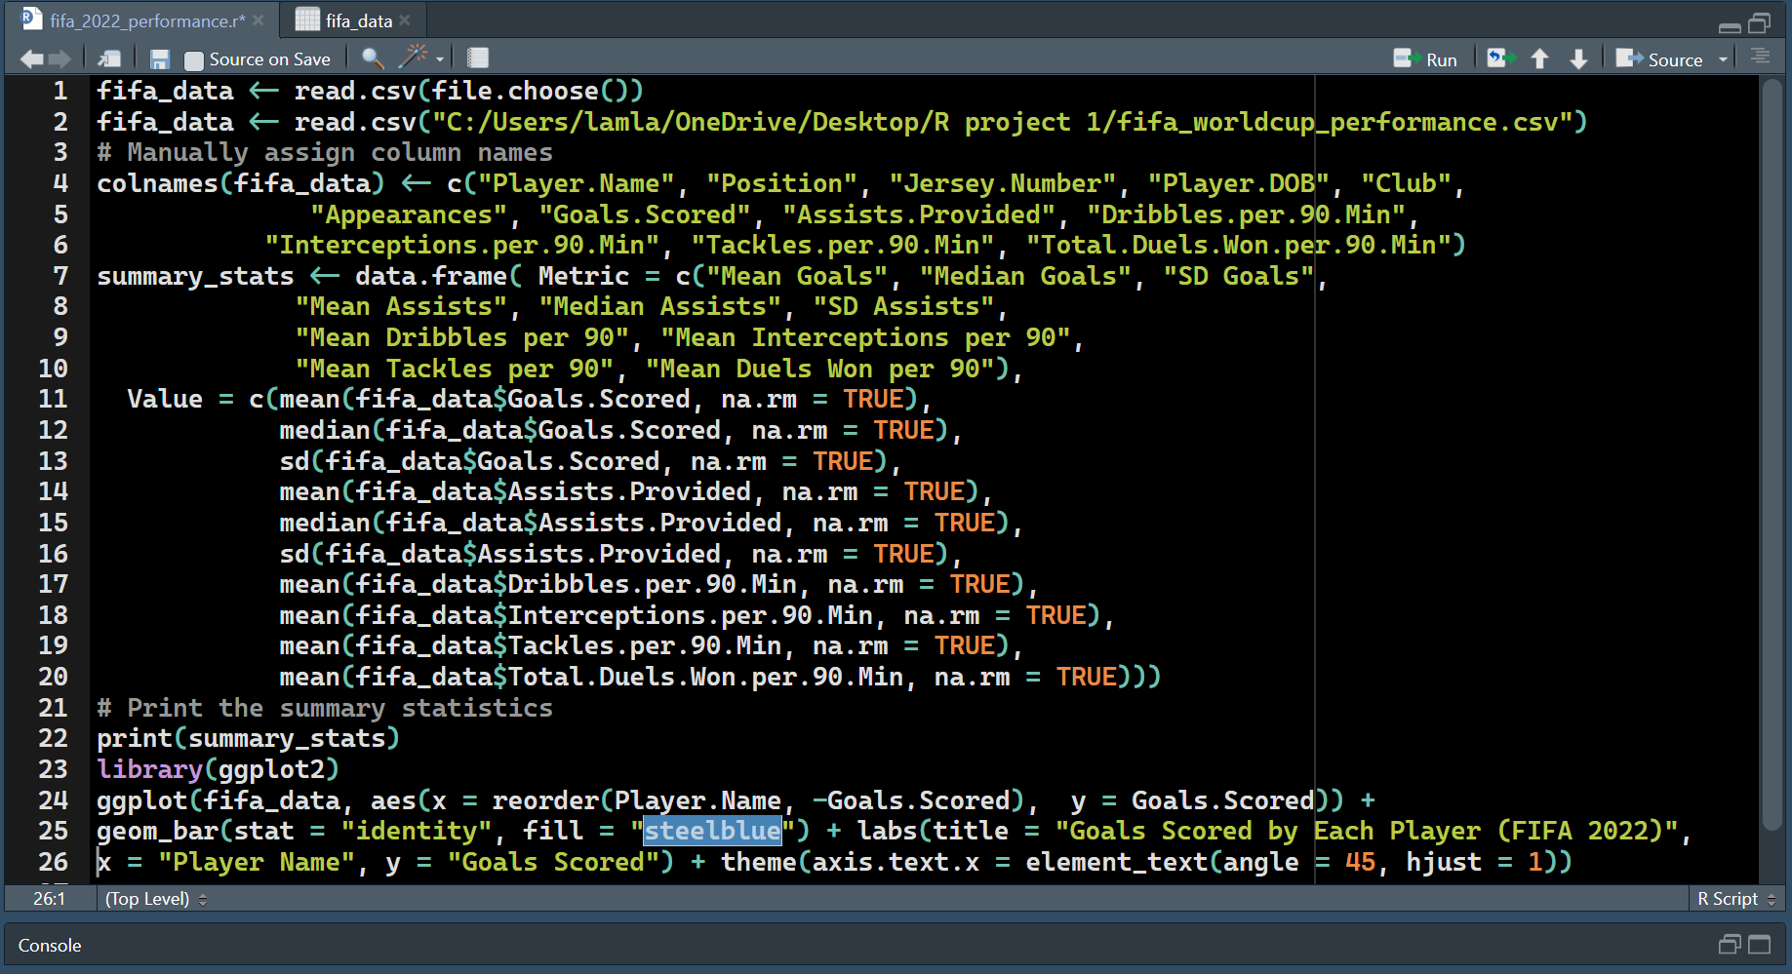

**References:**[**https://www.bing.com/ck/a?!&&p=af69ff43c2d83b3a7a62cb3680ba31f567ad9658168f5c68791c21eb9df9fa7aJmltdHM9MTc0NDY3NTIwMA&ptn=3&ver=2&hsh=4&fclid=05def05f-ec41-6ca4-19d4-e515edf36d0c&psq=data+collection+form+to+practice+in+excel&u=a1aHR0cHM6Ly93d3cuZXhjZWxkZW15LmNvbS9sZWFybi1leGNlbC9zYW1wbGUtZGF0YS8&ntb=1**](https://www.bing.com/ck/a?!&&p=af69ff43c2d83b3a7a62cb3680ba31f567ad9658168f5c68791c21eb9df9fa7aJmltdHM9MTc0NDY3NTIwMA&ptn=3&ver=2&hsh=4&fclid=05def05f-ec41-6ca4-19d4-e515edf36d0c&psq=data+collection+form+to+practice+in+excel&u=a1aHR0cHM6Ly93d3cuZXhjZWxkZW15LmNvbS9sZWFybi1leGNlbC9zYW1wbGUtZGF0YS8&ntb=1)[**https://www.exceldemy.com/wp-content/uploads/2023/12/2022-FIFA-World-Cup-Performance-Sample-Data.xlsx**](https://www.exceldemy.com/wp-content/uploads/2023/12/2022-FIFA-World-Cup-Performance-Sample-Data.xlsx)